AI Assisted Coding
Assignment-17
Name: B. Rithwik
HT No: 2303A52330
Batch: 35

Lab 17 – AI for Data Processing: Data Cleaning and Preprocessing Scripts Objective
- To clean raw datasets using Python and AI-assisted scripting.
- To handle missing values, remove duplicates, and standardize data.
- To encode categorical variables and normalize numerical data.
- To automate preprocessing tasks for efficient data analysis.
- To understand the importance of preprocessing in improving model performance.

Task 1 – Customer Data Cleaning Aim
To clean and preprocess a customer shopping dataset.

Procedure
- Loaded dataset using Pandas.
- Handled missing values in Age, Income, and City columns.
- Removed duplicate records.
- Standardized city names to lowercase.
- Encoded categorical variables such as Gender and City.

Code
import pandas as pd
df = pd.read_csv("shopping_trends.csv") df['Age'] = df['Age'].fillna(df['Age'].median())
df['Purchase Amount (USD)'] = df['Purchase Amount (USD)'].fillna(df['Purchase Amount (USD)'].mean())
df['Location'] = df['Location'].fillna(df['Location'].mode()[0])

df = df.drop_duplicates()

df['Location'] = df['Location'].str.lower().str.strip()
df = pd.get_dummies(df, columns=['Gender', 'Location'], drop_first=True) print(df.head())

Result
A cleaned dataset with no missing values, standardized text, and encoded categorical features.
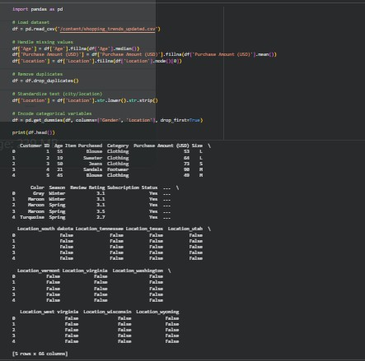

Task 2 – Sales Data Preprocessing Aim
To preprocess sales transaction data and create useful features.

Procedure
- Converted date column into datetime format.
- Extracted month, year, and day of the week.
- Normalized the sales column using Min-Max scaling.

- Detected and removed outliers using the IQR method.

Code
import pandas as pd
from sklearn.preprocessing import MinMaxScaler df = pd.read_csv("sales_data.csv")
df['date'] = pd.to_datetime(df['date'])

df['month'] = df['date'].dt.month
df['year'] = df['date'].dt.year df['day_of_week'] = df['date'].dt.dayofweek

scaler = MinMaxScaler()
df['sales'] = scaler.fit_transform(df[['sales']])

Q1 = df['sales'].quantile(0.25) Q3 = df['sales'].quantile(0.75)
IQR = Q3 - Q1
df = df[(df['sales'] >= Q1 - 1.5*IQR) C (df['sales'] <= Q3 + 1.5*IQR)] print(df.head())

Result
A transformed dataset with normalized values and additional time-based features.

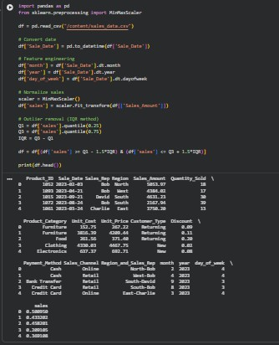

Task 3 – Healthcare Data Preparation Aim
To preprocess healthcare data for machine learning.

Procedure
- Filled missing values in blood pressure and cholesterol.
- Encoded categorical variables using Label Encoding.
- Scaled numerical features using Standard Scaling.
- Split dataset into training and testing sets.

Code
import pandas as pd
from sklearn.preprocessing import StandardScaler, LabelEncoder from sklearn.model_selection import train_test_split

df = pd.read_csv("healthcare_dataset.csv")

df['blood_pressure'] = df['blood_pressure'].fillna(df['blood_pressure'].mean()) df['cholesterol'] = df['cholesterol'].fillna(df['cholesterol'].mean())

le = LabelEncoder()

for col in df.select_dtypes(include='object').columns:
df[col] = le.fit_transform(df[col])

scaler = StandardScaler()
df[['blood_pressure', 'cholesterol']] = scaler.fit_transform(df[['blood_pressure', 'cholesterol']])

X = df.drop('target', axis=1) y = df['target']
X_train, X_test, y_train, y_test = train_test_split(X, y, test_size=0.2) print(X_train.shape, X_test.shape)

Result
A fully preprocessed dataset split into training and testing sets, ready for model training.
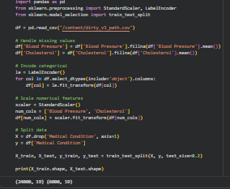

Task 4 – Employee Salary Data Preprocessing Aim
To clean and preprocess employee salary data for analysis.

Procedure
- Handled missing values using forward fill.
- Removed salary outliers using the IQR method.
- Standardized department names to lowercase.
- Encoded job location and department using Label Encoding.

Code
import pandas as pd
from sklearn.preprocessing import LabelEncoder df = pd.read_csv("employee_salary.csv")

df = df.fillna(method='ffill')

Q1 = df['salary'].quantile(0.25) Q3 = df['salary'].quantile(0.75)
IQR = Q3 - Q1

df = df[(df['salary'] >= Q1 - 1.5*IQR) C (df['salary'] <= Q3 + 1.5*IQR)] df['department'] = df['department'].str.lower().str.strip()
le = LabelEncoder()
df['job_location'] = le.fit_transform(df['job_location']) df['department'] = le.fit_transform(df['department'])

print(df.head())

Result
A structured dataset with cleaned and encoded features suitable for HR analytics.
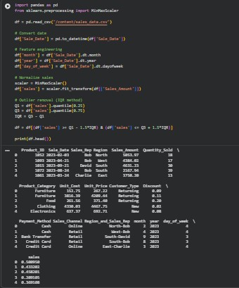

Conclusion
Data preprocessing is a crucial step in machine learning as it ensures data quality, consistency, and reliability. Proper handling of missing values, encoding, normalization, and outlier removal significantly improves model accuracy and performance.

